

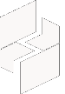

MICROSOFT ARCHITECTURE BEST PRACTICE FOR SECURITY
USECASE: FIRST LAYER OF DEFENSE USING AZURE SECURITY SERVICES

Document Title | Microsoft Cloud Center of Excellence Overview
Presales/Technical Head | Tushar Mehrotra/Rohit Pandey
CCoE Lead | Ravishankar N
Creation Date | JAN 2026
Version | Description | Modified by | Date | Approved by | Date
1 | Initial Architecture design | Ajeet Kumar | 15/01/2026 | Ravi Shankar | 15/01/2026
2 | Governance, Policy, and Monitoring | Ajeet Kumar | 18/03/2026 | Ravi Shankar | 18/03/2026
3 | Final Architecture design | Ajeet Kumar | 27/04/2026 | Ravi Shankar | 27/04/2026
Contents
1
1. Executive Summary 3
2. Scope and Applicability 3
3. Business Scenario Overview 3
4. Reference Architecture Overview 4
4.1 Architecture Description 4
5. Logical Architecture Components 4
5.1 Identity and Access Protection 4
5.2 Network-Level Security Controls 4
5.3 Compute and OS Security 4
5.4 Data Protection and Encryption 4
5.5 Application and Platform Security 4
5.6 Governance, Policy, and Monitoring 5
6. Architectural Best Practices 5
7. Cloud Center of Excellence (CCoE) Enablement Model 5
8. Reusability and Scalability 5
9. Conclusion 5

1. Executive Summary
This document is based on building the first layer of defense using Azure security services. The architecture focuses on foundational, cost-effective, and built-in security capabilities that help organizations protect cloud resources, identities, and data from common threats.
The solution applies the principles of defense in depth, zero trust, and secure by default, establishing a strong security baseline for Azure environments before introducing advanced threat protection services.

2. Scope and Applicability
This reference architecture applies to:
- Azure IaaS and PaaS workloads
- Enterprise and mid-market Azure environments
- Organizations establishing baseline cloud security controls
- Cloud adoption and early modernization initiatives
- CSP, enterprise IT, and CCoE-governed Azure platforms
The architecture emphasizes native and cost-free Azure security services wherever possible.

3. Business Scenario Overview
Organizations moving workloads to Azure often expose infrastructure to new attack surfaces, including identity compromise, network intrusion, and data leakage. Without a baseline security layer, these risks increase significantly.
This architecture addresses such challenges by defining a foundational security framework that mitigates:
- Credential and identity-based attacks
- Network-level threats
- Misconfiguration and policy drift
- Data exposure risks
By establishing the first layer of defense, organizations reduce breach likelihood and improve overall security posture.

4. Reference Architecture Overview
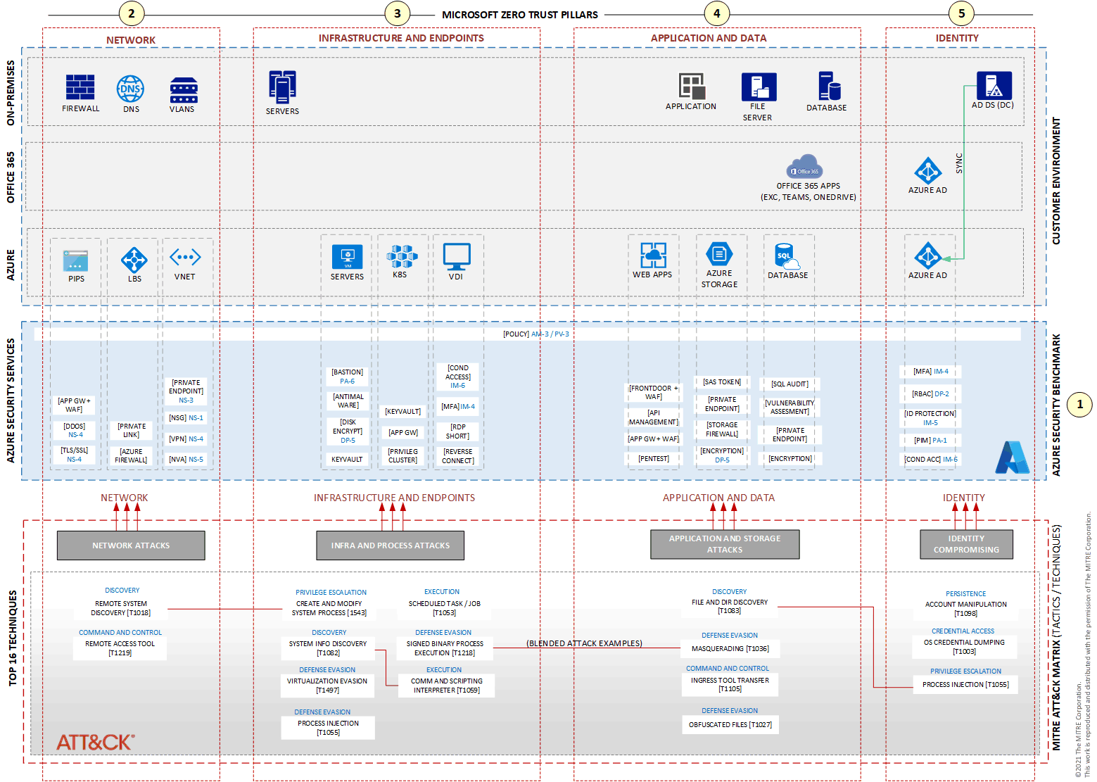

4.1 Architecture Description
The architecture organizes Azure security services by protected resource category, enabling targeted defense mechanisms for identities, networks, compute, storage, and applications. All services are aligned with the Azure Security Benchmark (ASB) v3, which consolidates security recommendations from industry standards such as CIS and NIST.
The solution is designed to be modular, allowing organizations to progressively enhance security maturity over time.

5. Logical Architecture Components

5.1 Identity and Access Protection
- Microsoft Entra ID for centralized identity management
- Multifactor Authentication (MFA) for strong authentication
- Role-Based Access Control (RBAC) for least-privilege access
Identity protection forms the first and most critical control plane in Azure security.

5.2 Network-Level Security Controls
- Network Security Groups (NSGs) for traffic filtering
- Azure DDoS Protection (Basic)
- Secure virtual network segmentation
These controls reduce the network attack surface and block unauthorized traffic.

5.3 Compute and OS Security
- Secure virtual machine configuration
- Disk encryption using Azure-managed keys
- Operating system hardening and patching
Compute-level protections ensure workload isolation and data confidentiality.

5.4 Data Protection and Encryption
- Storage Service Encryption for data at rest
- TLS/SSL encryption for data in transit
- Shared access signatures (SAS) for controlled access
These services protect sensitive data without requiring additional licensing.

5.5 Application and Platform Security
- Secure application endpoints
- Platform-level security features in Azure PaaS services
- Native authentication and authorization integrations
Application protections help prevent common web and API-based attacks.

5.6 Governance, Policy, and Monitoring
- Azure Policy for configuration enforcement
- Azure Monitor for centralized logging
- Security posture visibility and compliance tracking
Governance controls ensure security configurations remain consistent at scale.

6. Architectural Best Practices
This architecture aligns with the Azure Well-Architected Framework, particularly:
- Security – Defense in depth and secure defaults
- Operational Excellence – Standardized and automated controls
- Reliability – Reduced misconfiguration-related risk
Organizations should treat security as an iterative process that evolves with workload maturity.

7. Cloud Center of Excellence (CCoE) Enablement Model
The CCoE uses this architecture to:
- Define minimum security baselines for Azure deployments
- Enforce security policies across subscriptions
- Standardize identity, network, and data protection controls

8. Reusability and Scalability
- Applicable across multiple Azure subscriptions and regions
- Reusable baseline for all Azure workloads
- Scales from small environments to enterprise-scale deployments

9. Conclusion
The Azure Security – Build the First Layer of Defense Reference Architecture provides a Microsoft-aligned foundation for protecting cloud environments. By leveraging built-in Azure security services and established best practices, organizations can significantly reduce risk, improve compliance, and establish a strong security baseline for future growth.

